No diretório Providers\AppServiceProvider.php

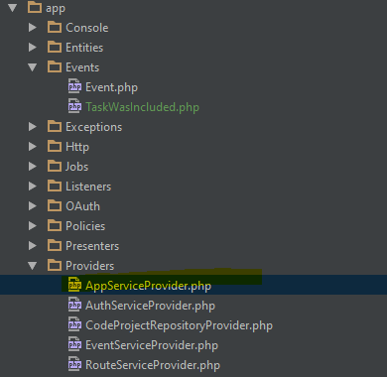

**<?php  
  
namespace** CodeProject\Providers;  
  
**use** CodeProject\Entities\ProjectTask;  
**use** CodeProject\Events\TaskWasIncluded;  
**use** Illuminate\Support\ServiceProvider;  
**use** Illuminate\Support\Facades\Event;  
  
**class** AppServiceProvider **extends** ServiceProvider  
{  
 */**  
 * Bootstrap any application services.  
 *  
 \** ***@return*** *void  
 */* **public function** boot()  
 {  
 //quando criar uma tarefa, pega ela  
 ProjectTask::*created*(**function**($task){  
 Event::*fire*(**new** TaskWasIncluded($task));  
 });  
 }  
  
 */**  
 * Register any application services.  
 *  
 \** ***@return*** *void  
 */* **public function** register()  
 {  
 //  
 }  
}

*\* Bootstrap any application services.  
 *  
 \** ***@return*** *void  
 */* **public function** boot()  
 {  
 //quando criar uma tarefa, pega ela  
 ProjectTask::*created*(**function**($task){  
 Event::*fire*(**new** TaskWasIncluded($task));  
 });  
 }  
  
 */**  
 * Register any application services.  
 *  
 \** ***@return*** *void  
 */* **public function** register()  
 {  
 //  
 }  
}